- MEDIA KIT

- PHOTO
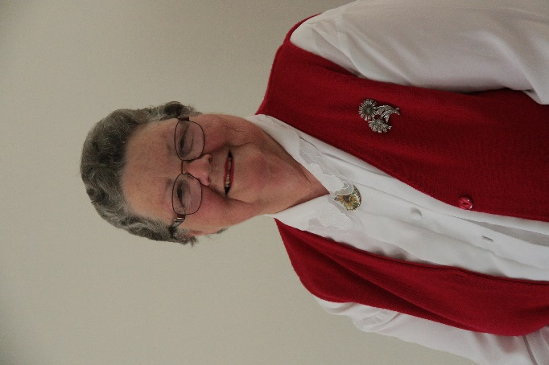
- BIOGRAPHY

Barbara is a retired Botanist, who has studied and worked in several Australian States. She was awarded a PhD in 1970, for her work on Australian native trees and shrubs.
She was born in a rural area of Queensland, one of Australia’s northern states. Her parents ran a mixed farm. She has warm memories of growing up there, with her three siblings, surrounded by horses, dogs, cats, cows and calves, pigs, and chooks. She attended a one-roomed country school for nine years, before moving on to boarding school for her secondary education.
She moved to Adelaide in the 1960s, and has remained there ever since. She is married, has two daughters and a grandson. She now lives in a Retirement village, while her husband is in care, as he suffers from dementia.
Barbara has always had a keen interest in writing. She was awarded prizes for her writing, in primary school, and in the Ipswich Eisteddfod. She had stories and poems published in School and University annuals. She published many scientific papers, and also published articles explaining scientific subjects to the general public.
She has researched and distributed unpublished Family History books among family members, with some of this work published in Family History magazines. She self-published an eBook on Kindle in 2018.

- BOOK BIOGRAPHY
Growing up in the 1950s, on the farm in Queensland, I was very deeply attached to the life.
In 1966, I moved to Adelaide to study, then married a local man, and have lived here for more than 50 years.
But my heart has always been deeply connected to the farm I left behind. Homesickness made me start writing down my memories, beginning probably 40 years ago. When my children were young, and I was ‘just’ a housewife, I spent years researching family history. That gave me an excuse to write our family history, and I was able to include some of my stories about the farm.
For the last 4 years, I have been living alone, while my husband has been in residential care, suffering severe dementia. Once again, I turned to writing to fill empty hours. The last months during the Covid epidemic has increased my isolation, and my childhood has seemed even more attractive. The text has grown, and eventually I asked Ocean Reeve whether he thought others would be interested to read about my childhood on the farm. The rest, as they say, is history … or my ‘her-story’.

- TARGET AUDIENCE

People most interested in this book will be those who farmed in the 1940s, 1950s, and 1960s, their families, and those interested in the history of small towns, especially in the Darling Downs of southern Queensland.
Anyone interested in Australian farming history will gain a rare insight into an important aspect of Australia’s past.

- ENDORSEMENTS
Jenny Old AUTHOR
www.jennyold.com
Barbara Randell’s Memoir of life on a farm in Central Queensland in the 1950’s, is beautifully written and describes a generation that I can relate to, but many cannot. Barbara’s descriptions made me feel I was there, experiencing the fresh fragrance of that first drop of rain on the corrugated roof following a dry spell, the sight of the dust rolling in, the sounds and beauty of the bush. This Memoir is an Australian Classic which records a post war era that few will actually remember in years to come. Congratulations Barbara on leaving a legacy for all to enjoy.
-------------------------

Glenys Brokenshire
Author of ‘Thicker than Water’.

Nobody would write about farming in the 1950s – it’s too ordinary!
But the ordinary becomes extra-ordinary when seen through the eyes of a ten-year-old Barbara Redgen, in Barbara Randell’s latest book, The Redgens of Redford.
Seen through young eyes and interpretated through a young enquiring mind, Barbara shows us her childhood on the family’s Queensland farm.

…………………………………………………

Trish Henningsen
Manager, Chinchilla History Museum

"The Redgens of Redford" is funny and informative. Barbara Randell has done an amazing job bringing us a way of life that is important in Australia's history. I particularly enjoyed your detailed descriptions of the shop interiors, and the shopping experience of the time.

………………………………………………………………
Margie Lee-Madigan
EST1889 Broadmere [ of Instagram]

Oh I am so pleased you touched base with me. I have enjoyed reading your pages. Geckos, push bikes to school and town shopping days all things I can relate to back to the old history here on our property and previous generations. My husband is actually in the process of reading your pages as he is a huge reader especially of Bush history. It is excellent!

……………………………………………………………………
Sue Wallace
Travel Writer and Editor

From snakes in the outside loo to being trussed up in a corset, Barbara Randell paints an intriguing picture of growing up on a Queensland farm in the 1950s.
Her new memoir, The Redgens of Redford is written with humour and detail as she recalls life on the 660-hectare property, 15kms from the small town of Chinchilla.
Barbara grew up with three siblings and a menagerie of pets including horses, dogs, cats, cows, pigs, and chooks.
I love the story of her pet dog, Tinker, the most unlikely working dog, who was terrified of cows and horses.
Great descriptions provide insight into the farming cycle and its hardships and triumphs.
You can also well imagine that one-roomed country school where Barbara attended for nine years before moving on to boarding school and then university.
And you can also feel her relief when that tight corset is discarded after a shopping expedition to town.
The retired botanist has recorded a time in Australia’s farming social history that’s important to preserve and in danger of being lost.
It’s a fun and informative read, well done!
​

- BOOK EXCERPT
“When the rains finally came, you could smell them long before they arrived. Bushmen said that cattle can sense rain many kilometres off. I believe it, because I am sure that I could smell it for at least a kilometre … an indescribable sweet smell of damp soil and rejoicing vegetation. An aroma to lighten any drought-depressed soul. Then came the first few slow drops, leaving huge clear impressions in the dust around my feet and on the brim of my hat. Then the scurry as more drops arrived, smaller but in a rush to obliterate all signs of their larger forerunners. Then I fled for whatever shelter was nearby but stayed where I could watch the wonder of it—clear water falling from the sky where a moment before there was only air.
The first rush of the raindrops slowed to a steady fall. I could almost see the soil opening its pores to engulf the water. But soon it collected in hollows everywhere I looked, puddles filling and overflowing and joining, then becoming baby streams, to creep chuckling and laughing across the yard, joining into adolescent gullies with deeper voices, running to find their mates on the lower ground.
And then, if the rain continued, the gullies deepened their voices, deepened their streams, ran and rushed and fell until they reached the creek bed and joined together to make the roaring torrent we called a flood. A flood that shouted with excitement, tossed trees as if they were toys, caught animals and tormented them for sport, gouged great holes in the banks just to show its strength. And if the rain still fell, the flood grew deeper and stronger, climbed out over the banks of the creek, strode over the lands beyond, swept away fences and bridges and buildings, wiped its lines of foam around the trunks of trees half a kilometre from the creek bed.”

- INTERVIEW QUESTIONS
Why did you write this book?
What are your earliest memories of the farm?
Do you have more stories about life on the farm?
Do you still have family members living on farms?
Are there many other books about life on farms?
Why did you go to Boarding School? And that particular one?
Do you have a garden? If so, what do you grow?
Are you still interested in botany?
Are you worried about climate change?
Where can people buy your book?
Will there be another book?

- CONTACT INFORMATION
contact Barbara Randell:
email: brandell68@yahoo.com.au
phone: 0406500747
website: barbararandell.com
postal address: 25/30A Norfolk Road, Marion SA 5043

